**Practical 7**

Aim: Morphological Image Processing.

1) Program to apply erosion, dilation, opening and closing.

Program:

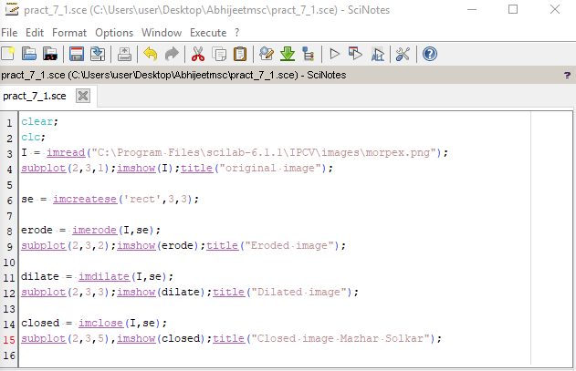

Output:

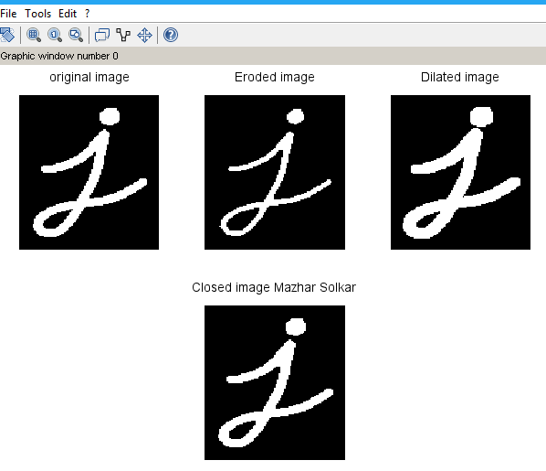

2) Program for detecting boundries of an image.

Program:

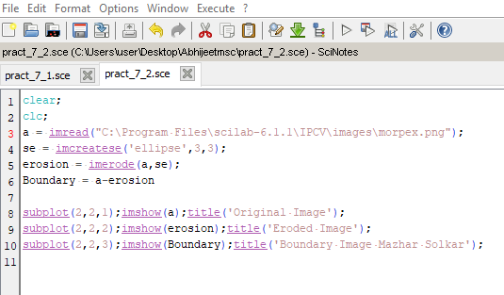

Output:

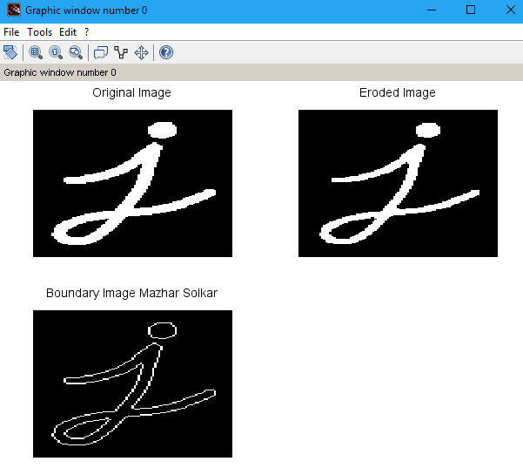

3) Program to apply Hit-or-Miss transform.

Program:

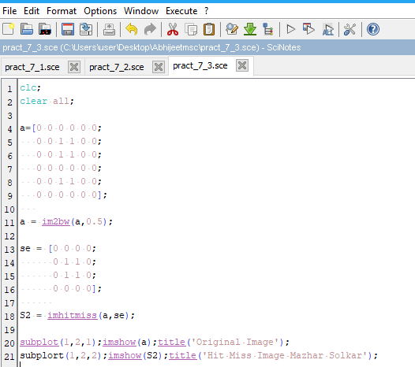

Output:

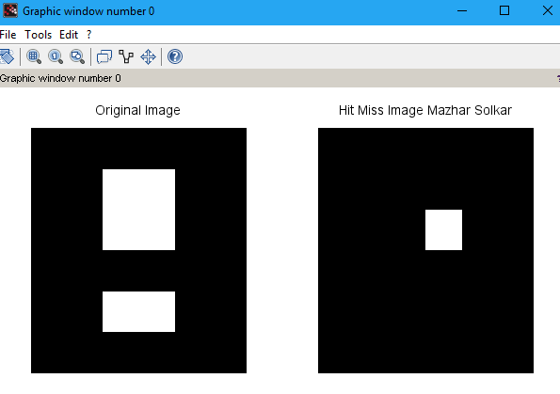

4) Program to apply morphological gradient on an image.

Program:

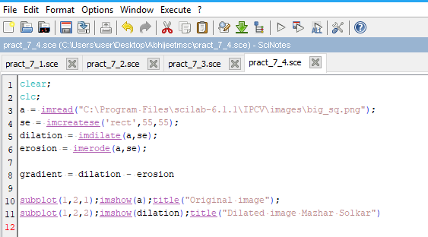

Output:

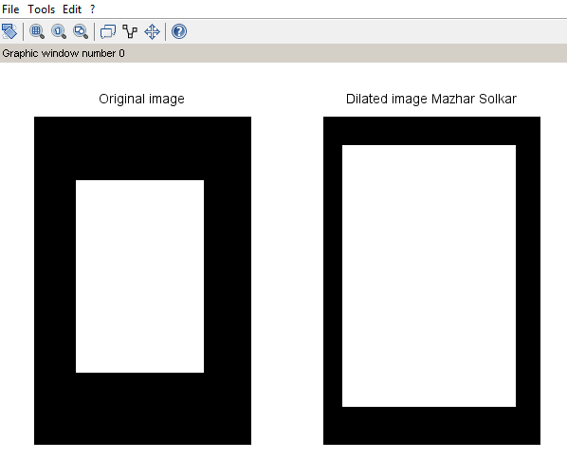

5) Program to apply Top-Hat/Bottom-hat Transformations.

Program:

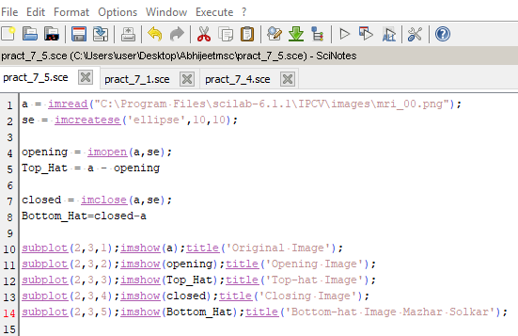

Output:

